
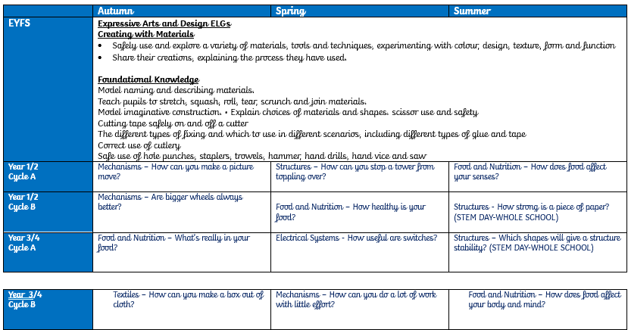
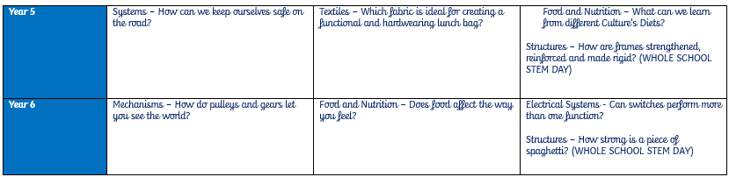
At Medlar-with-Wesham C of E we are Designers!

We want our children to love Design and Technology. We want them to be ambitious and feel confident enough to access roles as architects, graphic designers, chefs or carpenters
Design and Technology is dynamic and multidimensional. It is our intention that our DT curriculum will provide opportunities to solve real and relevant problems, allowing our pupils to develop resilience and essential everyday skills and unlock their potential to be the designers and innovators of tomorrow. The DT curriculum will encourage children to be curious about their learning and to think and intervene creatively to solve problems both as an individual and as part of a team.
Design and Technology will allow all Medlar with Wesham pupils to put their learning from other areas of the curriculum into practice, and will work to enhance and deepen their understanding of those areas, including maths, computing, science, and art.
Our pupils will learn about cooking, food and nutrition, ensuring that they acquire the fundamental life skills in order to be able to feed themselves healthily and independently, whilst learning about where food comes from, therefore making connections with their geographical and scientific knowledge.
"Design is not just what it looks like and feels like. Design is how it works."
Steve Jobs, co-founder of Apple, Inc.

Our Art and Design curriculum is created to evoke children’s curiosity, inspire and challenge pupils, whilst equipping them with the knowledge and skills to be able to experiment, invent and create their own works of art. As pupils progress, they should gain a deeper understanding of how Art and Design reflects and shapes our history, and how it contributes to the culture, creativity and wealth of our world.
We want our children to love Art and Design! We want them to have no limits to what their ambitions are and to grow up wanting to be illustrators, graphic designers, fashion designers, curators, architects or printmakers.
Our Art Curriculum will develop their resilience and prepare them for the opportunities, responsibilities and experiences of later life. Our curriculum allows children to study a wide range of unique and diverse artists, craft makers and designers; allowing them to be motivated by their different styles and techniques and use these confidently to inspire their own pieces of art.

“I found I could say things with colour and shapes that I couldn’t say any other way—things I had no words for.” Georgia O'Keefe

“Art develops spiritual values and contributes a wider understanding to the experience of life, which helps to build a balanced personality.” Bridget Rile, Painter

Intent
Curriculum Coverage
Design and Technology
And whatever you do, in word or deed, do everything in the name of Lord Jesus, giving thanks to God the Father through Him.
Colossians 3:17
Curriculum
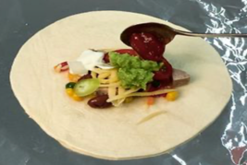
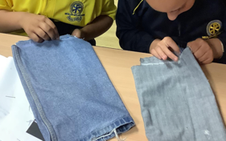
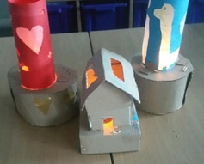
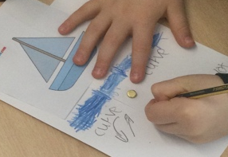
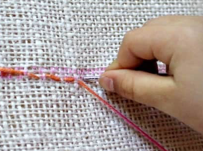
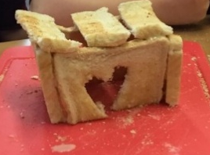
- Retrieval practice activities
- Assessment for learning during lessons
- Self and Peer critiques.
Assessment
Books
- Date and Key Questions evident.

- Knowledge organiser at the beginning of each new topic.

- Key vocabulary identified and highlighted in each lesson.
Examples of Work
Connected | Cumulative | Coherent
 |  | 
Our work is built around | We believe learning isn’t an | Sequence matters
cognitive load theory | event. It must be knowledge- | systematically planned
principles of instruction | rich, vocabulary-rich | explicit instruction
evidence informed practice | and skilful | supports acquisition of curriculum content

Learning Model
Intent
Impact
Expectations
And whatever you do, in word or deed, do everything in the name of Lord Jesus, giving thanks to God the Father through Him.
Colossians 3:17
Curriculum

