

EYFS Foundational Knowledge
- Listen attentively, move to and talk about music, expressing their feelings and responses.
- Watch and talk about dance and performance art, expressing their feelings and responses.
- Sing in a group or on their own, increasingly matching the pitch and following the melody.
- Explore and engage in music making and dance, performing solo or in groups.
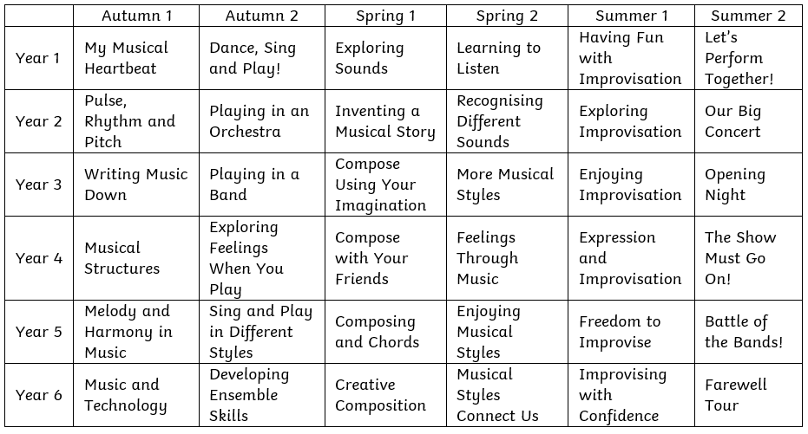
At Medlar-with-Wesham Primary School our music curriculum intends to inspire curiosity, creativity and self-expression to become resilient and confident musicians. We want to encourage our children on their musical journeys as well as giving them opportunities to connect with others. We want our children to love music. We want them to have no limits to what their ambitions are and grow up wanting to be music producers, songwriters, composers or rockstars!

Our vision, at Medlar-with-Wesham, is to give children access to an engaging and fun music curriculum reflecting the world they live in now, but at the same time giving them access to musical styles throughout history. Children are able to listen and appraise a variety of musical styles alongside performing pieces and creating their own compositions through the use of technology. To achieve this all children access a variety of musical games, songs, instruments, music workshops, and extra - curricular activities giving them practical hands on experience.

We hope children continue to grow in confidence as they progress through the musical curriculum and become passionate in their responses to music. Added to this we want children to become more independent learners within this area, reflect upon their learning and develop resilience within the musical world.

A singing culture will be established and nurtured within the school. Children and adults in the school will be encouraged to sing whenever appropriate to aid well-being and health as well as musical outcomes.

Intent
Curriculum Coverage
Music
And whatever you do, in word or deed, do everything in the name of Lord Jesus, giving thanks to God the Father through Him.
Colossians 3:17
Curriculum
Wider Opportunities
Examples of Music Around School
Evidence
- Flute lessons with LMS in Y5
- Choir
- Young Voices Concert
- Big Sing at Lowther Pavilion
- Performing at local care homes
- Pictures and Videos of performances saved on teacher share folder

- Key vocabulary identified and highlighted in each lesson.
Connected | Cumulative | Coherent
 |  | 
Our work is built around | We believe learning isn’t an | Sequence matters
cognitive load theory | event. It must be knowledge- | systematically planned
principles of instruction | rich, vocabulary-rich | explicit instruction
evidence informed practice | and skilful | supports acquisition of curriculum content

Learning Model
Intent
Impact
Expectations
And whatever you do, in word or deed, do everything in the name of Lord Jesus, giving thanks to God the Father through Him.
Colossians 3:17
Curriculum

